Ravan Muradzada

- The wheel group in Linux is technically just a normal group like any other group in the system. There is no huge built-in difference in how the kernel treats it. The difference comes from how the system administrator configures it. The wheel group is commonly configured in the `/etc/sudoers` file to control administrative access. Inside that file, there is usually a line like:
%wheel ALL=(ALL) ALL
This line means that any user who is a member of the wheel group is allowed to use sudo to run commands as root or as another user.

- First, to let users use these commands, we need to find their paths using `which` command:
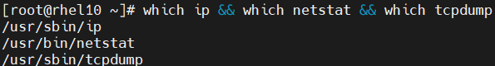
Let’s create a new user named “networker”:
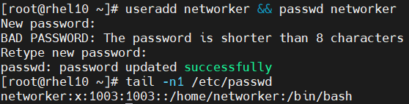
We go to `/etc/sudoers.d` directory and create a file named `networker` here and open it to write these:
BTW: Here command name cannot contain lowercase letters. (It failed when it is)
Then we can run the commands specified here with the usage of `sudo`:
(I will not show full output, because it is long)
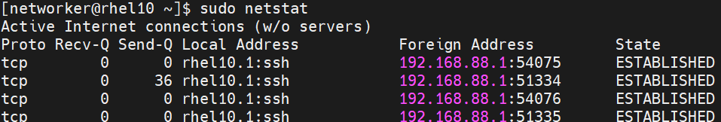
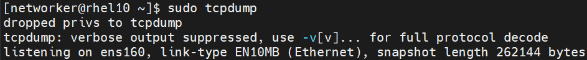
BTW: Among these commands, only `tcpdump` need sudo permission to run. Others can be run without sudo.

- I have created a directory inside root directory named `/WorkingDir` and created my script file inside it:
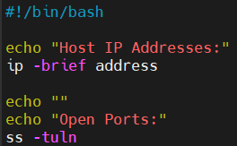 This is the content of script file.
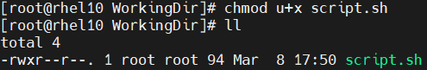
As you can see, only root can execute this command. Others need to have sudo access for it.
Let’s create `scriptrunner` user:
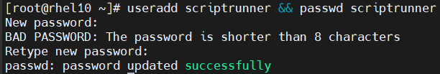
Let’s add him to sudoers.d. We create a file named `scriptrunner` inside `sudoers.d` directory and type it there:
When this user goes the specified directory and runs the script with `sudo`, it will work:
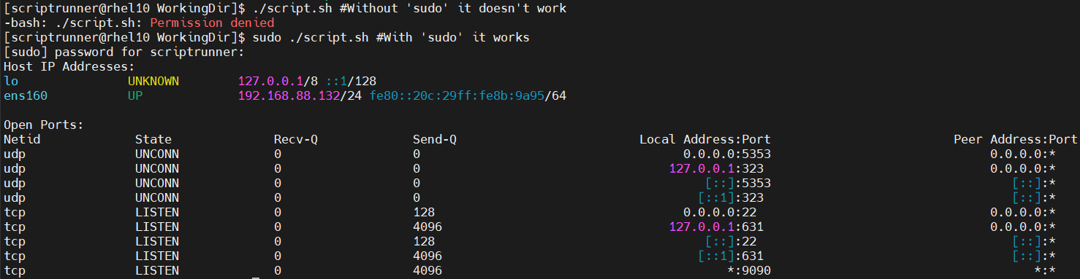

- 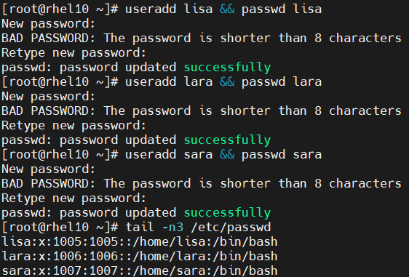

- I have set passwords in Task 4. Looking at above, I did it there using `passwd` command.

- 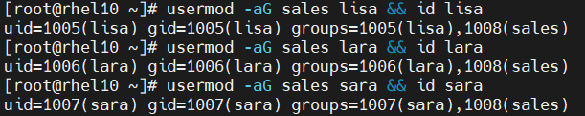
`usermod -aG <GROUP_NAME> <USER_NAME>` helps us here.

- 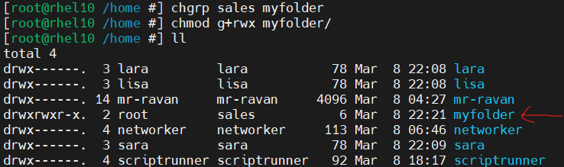

- 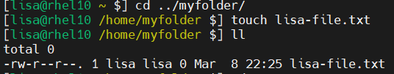

- As you can see, the group owner is lisa herself.

- 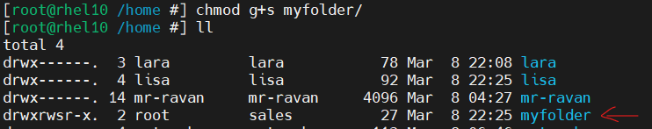

Using `chmod g+s <DIRECTORY_NAME>`, we can set a group collaboration.

- 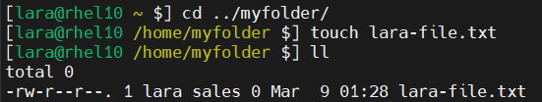

- As you can see (in task 15, above), the group owner of the file is `sales`. It happens because we set group collaboration for its parent folder.

- 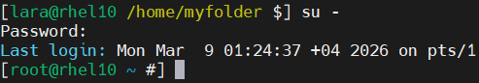

- 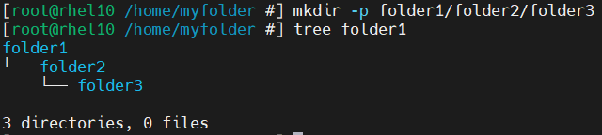

- 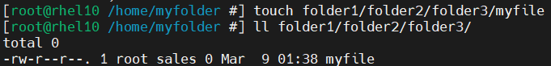

- We just need to use `setfacl -m g:wheel:rw <PATH>`. I will show the command in Task 21.

- 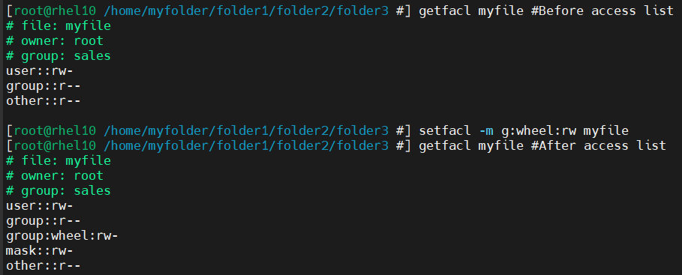

- We need to use Sticky Bit here: `chmod o+t <DIRECTORY_NAME>`.
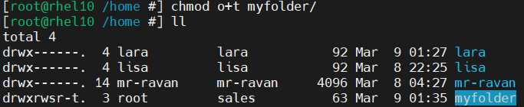
So, when Sara tries to remove Lisa’s file:
When we implement Sticky Bit to parent directory, a file can be removed only by its creator or root user.

`chattr +I <PATH_TO_FILE>`
We use `i` attribute, it makes files immutable. So, nobody can delete them. If we want to delete it, root should remove this attribute.

- 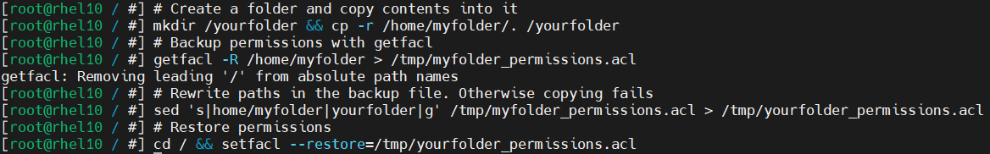
As you can see, first we create a folder and copy the contents from `/home/myfolder` to here. Then get the permissions with `getfacl -R /home/myfolder` and redirect it to `/tmp/myfolder_permissions.acl` to save as backup.
We use `sed` command to rewrite paths to prevent confusion in system. At last, we apply changes using `setfacl –restore=/tmp/yourfolder_permissions.acl`.

If we go to `/yourfolder` with `cd` command, run this command:
We will see that all permissions are successfully applied here.
What does `sed` command do here?
`sed` here acts as a path rewriter. It reads the ACL backup file and replaces every occurrence of home/myfolder with yourfolder so that when setfacl --restore runs, it applies the permissions to /yourfolder instead of the original /home/myfolder.
Without sed, setfacl would try to restore permissions back onto the original home/myfolder paths, defeating the whole purpose of the task.

- Our command to switch between users is su. Without any argument it tries to switch to root user. There are two types of su command: su <USERNAME> or su - <USERNAME>.
su <USERNAME> → Switches user but keeps your current environment (PATH, variables, working directory). We never use it in real life.
su - <USERNAME> → Switches user and loads that user’s full login environment (like a fresh login). It changes HOME, PATH, shell settings, and moves you to that user’s home directory. We always use it in real life.

- 555 → r-x r-x r-x; 400 → r-- --- --- ; 750 → rwx r-x ---

- Umask shows us default permissions for files and directories when we create them. Its default value is 0022. We calculate permissions for files from 666, for directories it is 777. We basically subtract umask value from these and find the default permissions for files and directories.

Imagine our umask is 011. Then for files default permission is 655, for directories it is 766.

- The `/etc/skel` directory (skeleton) is a template directory for new user home directories. When you create a new user with useradd, the contents of /etc/skel are automatically copied into the new user's home directory. `.bash_profile`, `.bashrc`, `.bash_logout` are example files from this directory.

- We need to go to `/etc/skel` directory and create a script file here. I created a script file named “mylogout.sh” and add these:

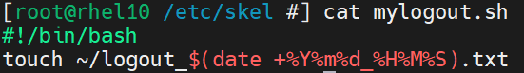

We should make it executable file using: `chmod +x mylogout.sh`
To ensure this file runs in logout, we need to add this line to `/etc/skel/.bash_logout`:
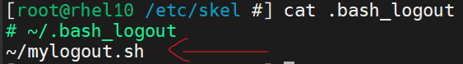

`bash_logout` file is read when the user logs out. So, by adding this line to `bash_logout` inside `/etc/skel` make sure our script file will run whenever user logs out.

Checking:
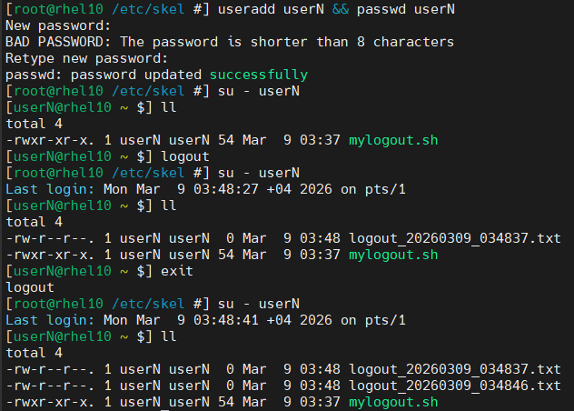
The script creates a new uniquely named file each time the user logs out (timestamp prevents overwriting).

- 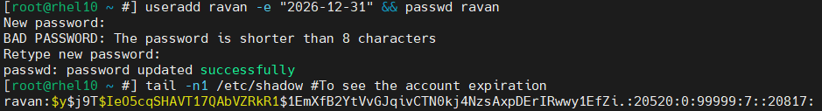
We use `-e` option in `useradd` to set expiration date for an account.

- To solve this task, we need to go to `/etc/login.defs` file and edit specific lines there. I show edited lines from this file:
